Jay, Alex (from Blue Chip Forest Services website)

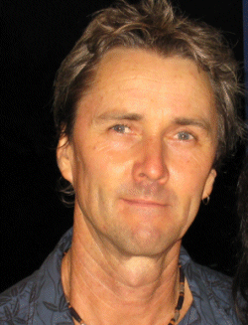
Bachelor of Science (Forestry) Australian National University 1980, Grad.Dip.Ag.Econ. University of New England 1992. Currently enrolled Ph.D Southern Cross University.
Forestry and natural resources consultant 25 years. Extensive Australian and international experience in development of Kiri (Paulownia) forestry projects. Worked as research forester and university lecturer, and has undertaken projects for a diverse range of clients including State and local government, corporate land-managers and private farmers. He operates a successful plantation management and natural resource consultancy business in northern NSW.
Technical Assistant CSIRO Fire Research 1980. Tree Planting Team Supervisor Tasmania 1981. Research Forester Melville Is NT 1981-1985.Natural Resources Consultant 1985- . Orchardist/Farmer Kyogle 1985-1996. Tertiary Lecturer NRCAE Lismore 1986-1988, Project Officer NSW NPWS Kyogle 1988-89. Forestry Consultant 1996- . Principal Consultant for Kiri Forestry Enterprises Pty Ltd also T/as BlueChip Forest Services specialising in Forest resource mapping and inventory, Plantation management services, Environment and sustainability assessments. Lecturer , tutor and research consultant 2003- 2006 Southern Cross University Lismore NSW.
Member of Australian Forest Growers (AFG) (current Nthn NSW branch president), Institute of Foresters of Australia (IFA)

